Name: Umar Tariq
Reg No: 2022604
Faculty: Cyber Security

Task 1:

Part a)i)
- Checking the permissions of the file:
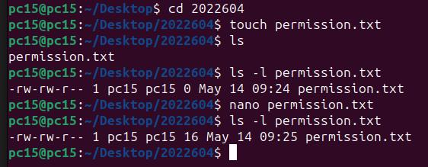

- Allowing write only permissions to the owner and others:

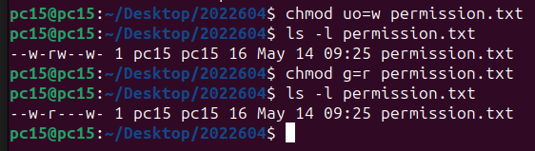

- Reset all the permissions for all users except owner:
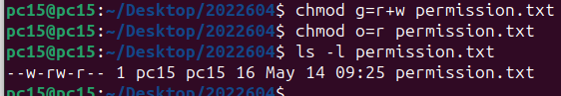

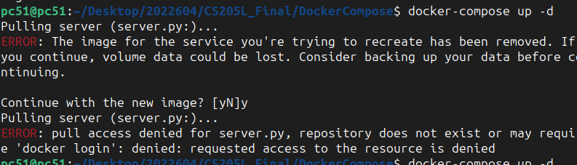
ii) Created a file and inserted a data in that file named as wordlist.txt:
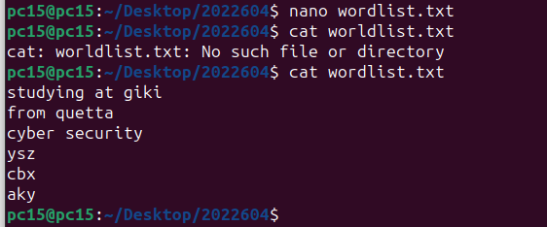

- Command to display the 3 letter words:

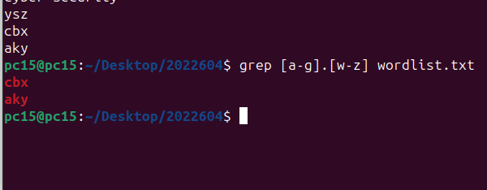

Part b) Performing debugging:

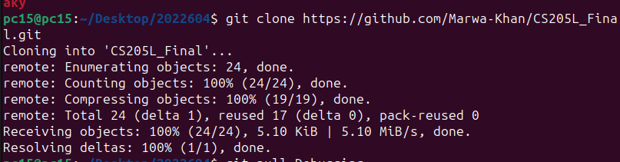

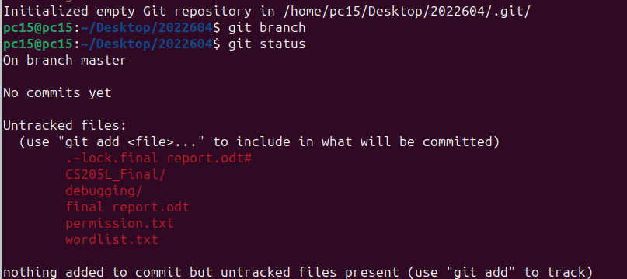

Task 1 b)

So the issue is of infinite loop.

Decrementing the d so that it could stop the loop:

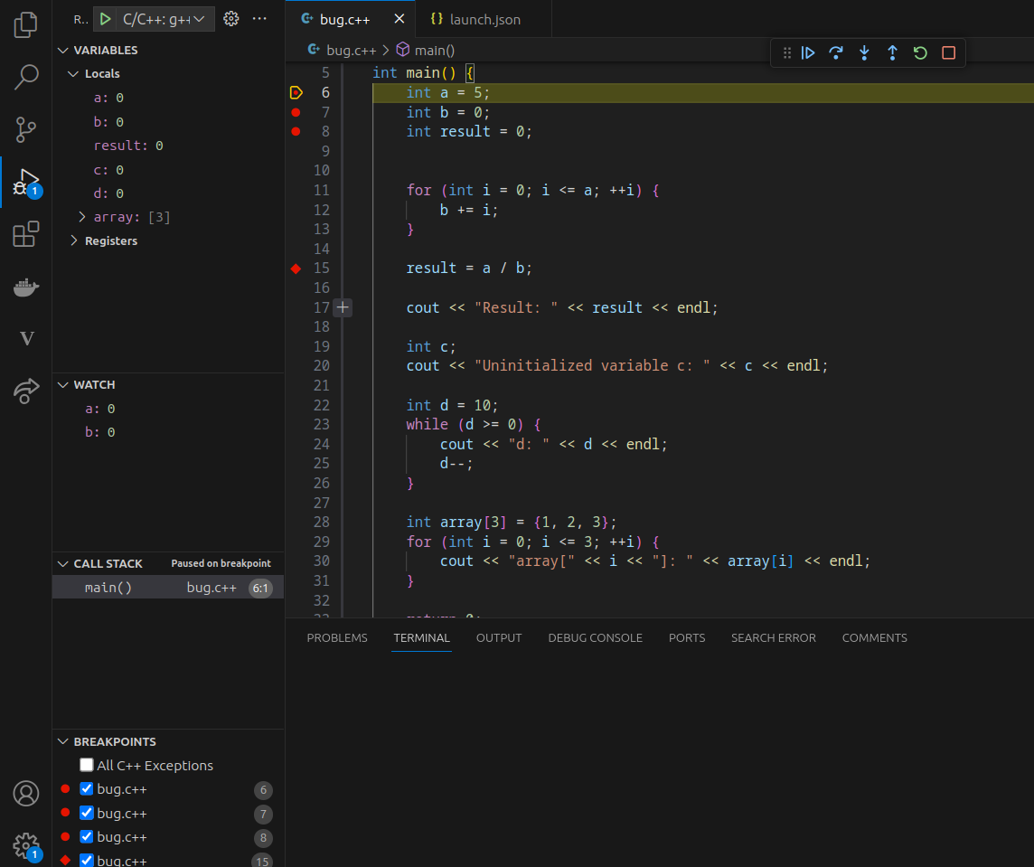

Task 2:
Docker Compose.yml

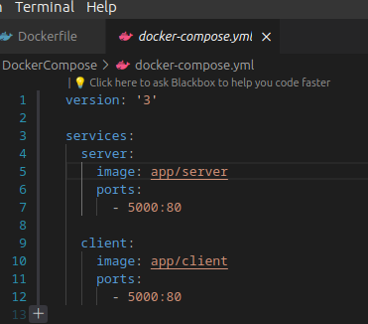

Using docker-compose config

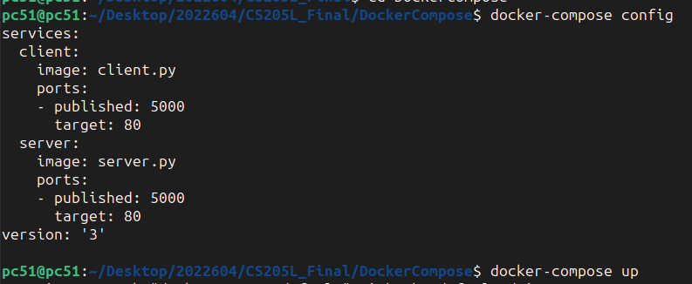

Creating the container to run:

Task 3:

Creating a docker file.

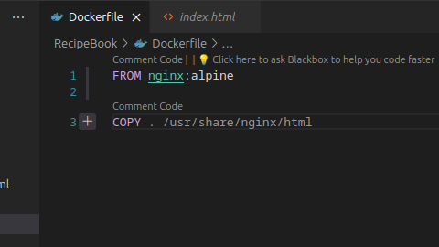

Running command to build image:

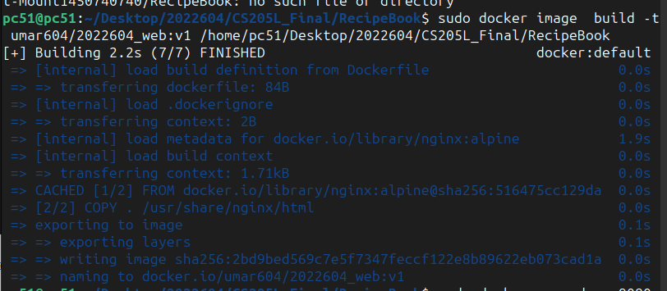

Image Created:

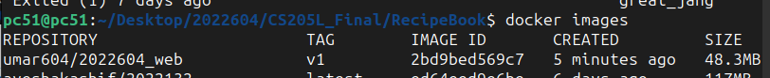

Running the container:

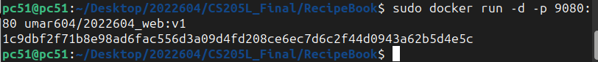

Container is running:

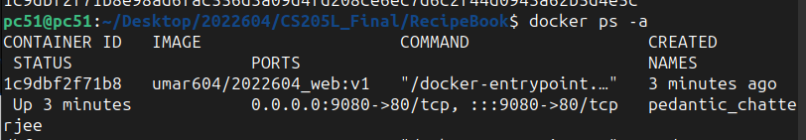

Container is running on port 9080:

